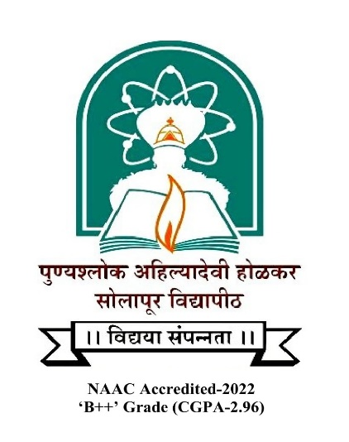

Punyashlok Ahilyadevi Holkar Solapur University, Solapur

**Criterion III – Research, Innovations and Extension**

Key Indicators – 3.6 Extension Activities

|  |  |
| --- | --- |
| **Metric No.** |  |
| **3.6.3** | ***Number of extension and outreach programs conducted by the institution including those through NSS/NCC/ Government and Government recognised bodies during the year*** |
|  | |  |  | | --- | --- | | **Year** | **2022-23** | | **Number** | **02** | |