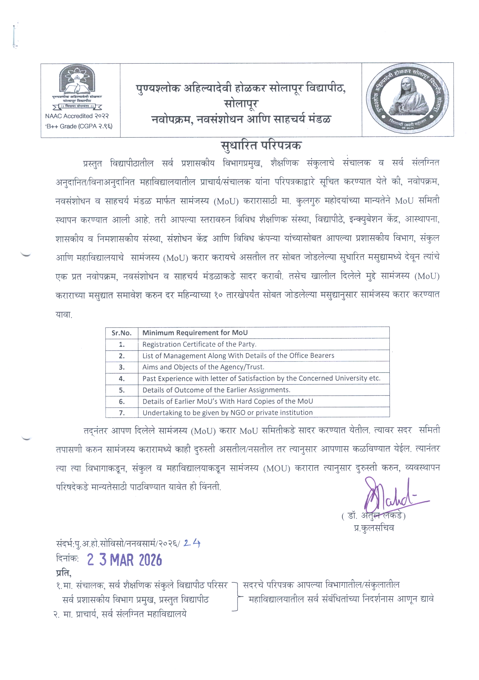

Sr. No. | Minimum Requirement for MoU | Endorsement by  Director / Head of Department
1. | Registration Certificate of the Party
2. | List of Management along with details of the Office  Bearers
3. | Aims and Objects of the Agency / Trust
4. | Past experience with letter of satisfaction by the  concerned university etc.
5. | Details of Outcome of the Earlier Assignments
6. | Details along with Hard Copies of Earlier MoU
7. | Undertaking to be given by NGO or private institution

Letter of certification to be submitted by the Directors of the respective School/s/ Departments/ Centre etc. of Punyashlok Ahilyadevi Holkar Solapur University.

To,

The Chairman,
MoU Cell,
Punyashlok Ahilyadevi Holkar Solapur University,

Solapur. Respected Sir,
This is to certify that, I have gone through the details and necessary documents of the institute / college/university etc. _(name institution/college/university etc.) and found it true and correct to the best of my knowledge and belief.
Therefor you are requested to consider and approve the MoU draft. Thanking you,

Yours sincerely,

(Name_________________ )
Designation and Seal

MEMORANDUM OF UNDERSTANDING

THIS MEMORANDUM OF UNDERSTANDING (hereinafter referred to as “MoU”) is executed on this---------Day of 2--, at Punyashlok Ahilyadevi
Holkar Solapur University, Solapur.

BETWEEN

Name of The Trust / University / College / Institution bearing (details of registration)
having its office at ,
State, India, hereinafter referred to as “ -------------------”, represented through
-----------------------------------------aged, ------- years working as
------------------ of the First Party;

AND

PUNYASHLOK AHILYADEVI HOLKAR SOLAPUR UNIVERSITY, SOLAPUR
Established in 2004, Non-Agricultural State University, having its registered office at Kegaon, Solapur, Pune National Highway, Solapur- 413 255 hereinafter referred to as “PAHSUS” represented through Registrar (which expression shall unless the meaning or context otherwise requires shall mean and include its successors and assigns) of the Second Party;

Scope:
First Party & Second Party believe that for providing a better platform for students and stake holder including students from the university campus school, departments
/ center of institution and also the students from the various affiliated colleges / institutions and also the students from the autonomous college / institution etc. within the jurisdiction of this university to give better opportunities in various fields of education and interdisciplinary research etc. the collaboration and co-operation between themselves will promote more effective use of each of their resources, and provide each of them with enhanced opportunities.

Objectives of the MoU: (to be filled by the Director / Heads of the Schools of this university)

- Areas of collaboration: (to be filled by the Director / Heads of the Schools of this university)

Proposed modes of collaboration: (to be filled by the Director / Heads of the Schools of this university)

- Nature of Activities: ( Nature of Activities and duration for such activity along with the expenses for such activity are to be filled by the Director / Heads of the Schools of this university)

Terms and Conditions:
  - All activities shall be executed only after written consent of both the parties.
  - If the any of the college/institution etc. as mentioned in Scope wants to participate in the activity pursuant to this MoU, separate MoU is required to be signed by and between the college / institution and the First Party and both the parties shall inform about such activity to the University / Second Party well in advance.
  - This Memorandum of Understanding reflects the respective institutions' commitments to the terms and conditions mentioned in the MoU. This MoU shall remain in effect initially for years and thereafter and can be renewed after
taking review for another period as agreed by both the universities. This MoU may be amended or terminated at any time by either Party provided that written notice of termination or amendment is given by the notifying Party to the other Party before (90) days of the date on which the termination or the amendment is intended to become effective. The commitments, made before the date of termination of MoU, shall continue to be operative.

  - (School may add any other conditions as it deems fit either on their own or after consultation with the MoU cell as the case may be.)
- Financing : (to be filled by the Director / Heads of the Schools of this university, the concerned school should specifically mention the approximate cost and expenses for each activity defined in above Nature of Activities at Sr. No. 4 along with respective Heads / Titles of expenses also specifying the share of each party to this MoU)

Nomination of Coordinators: (to be filled by the Director / Head of the Schools of this university)

- Arrangements for visiting officials: (to be filled by the Director / Head of the Schools of this university)

Use of Names.
Except in promoting the activities proposed in Article 1.1 above among its faculty, staff, and students, neither Participant may use the name of the other Participant in any form of advertising or publicity without express written permission. seek permission from one another by submitting the proposed use, well in advance of any deadline, also any activity for which the certificate and or memento is to be awarded to the participants it shall carry the name and logo of both the parties to this MoU.

Relationship Between The Parties
It is expressly agreed that First Party and Second Party are acting under this MoU as independent contractors, and the relationship established under this MoU shall not be construed as a partnership. Neither Party is authorized to use the other Party’s name in any way, to make any representations or create any obligation or liability, expressed or implied, on behalf of the other Party, without the prior written consent of the other Party. Neither Party shall have, nor represent itself as having, any authority under the terms of this MoU to make agreements of any kind in the name

of or binding upon the other Party, to pledge the other Party’s credit, or to extend credit on behalf of the other Party.

Confidentiality.
In the course of the activities under this MoU it may be necessary for the Participants to disclose Confidential Information. Unless otherwise expressly permitted in this agreement, any and all information, correspondence, financial statements, records, data, or information that is competitively sensitive and not generally known to the public, including formulations, analysis, inventions, improvements and activities of the disclosing Participant, disclosed by one Participant to the other Participant of this MoU, and other documents transmitted or communicated by either Participant to the other Participant that is marked as confidential or proprietary for the purposes of this agreement (“Confidential Information”) shall be received and treated in confidence, and shall not be used by the receiving Participant or disclosed by the receiving Participant without the prior written consent of the disclosing Participant, which consent shall not be unreasonably withheld or delayed. These restrictions on use or disclosure of information do not extend to any item of information which (a) is publicly known at the time of the disclosure, (b) is lawfully received by the receiving Participant from a third party which does not have a confidential relationship to the disclosing Participant, (c) the receiving Participant can demonstrate was in its possession or known by it before its receipt from the disclosing Participant, or (d) the receiving Participant is required by law to disclose to government authorities (including courts). Unless otherwise required under a subsequent binding agreement, each receiving Participant shall, at the expiry or termination of this agreement, return to the disclosing Participant any and all documents provided by the disclosing Participant setting out as Confidential Information.

Intellectual Property Rights:
All Intellectual Property (including but not limited to trade secret, copyrights and patents, etc. if any) of either Party in existence on the effective date shall remain the property of their respective owner/party. Ownership of any and all Intellectual

Property developed or created by or for a Party after the effective date as part of the delivery of the services or performance under this MoU shall be decided on case- to-case basis depending on the contribution of the Party to develop the same with a separate written agreement signed between the Parties.

Amendment
The present Memorandum of Understanding can be amended by the Parties through mutual consultation. The amendments shall be enclosed with the present Memorandum of Understanding and shall form an integral part of it thereof.

Validity & Termination
This MoU shall be valid for ----- years. The Memorandum of Understanding will enter into force on the date of signing and shall remain in force throughout the period or unless revoked by the consent of the Parties. Either of the Parties may terminate the present Memorandum of Understanding by giving the other party a written notice of ninety days in advance of its decision to terminate this Memorandum of Understanding. Termination will not affect activities covered by a collaborative contract between the executive agencies and already underway at the time of termination.

On receipt of any complaint about the (name of the institution/NGO the university)

the university has every right to take action in this regard & shall have power to

impose penalty or to terminate the MOU

Settlement of Dispute
Any disputes arising out of the implementation or interpretation of the provisions of this Agreement and or dispute relating to any aspect of academic cooperation shall be settled amicably or will try to jointly resolve the dispute if any by direct negotiations between the top officials of the first and second party to this MoU at the place mutually agreed between them / at Solapur as the case may be.

Non-Binding Nature.
This MoU is not intended to and does not give any person who is not a Participant

to it any rights to enforce any of its provisions. Nothing in this MoU will be construed as creating a binding legal relationship between the Participants, with the exception of condition which will survive the expiry or termination of this MoU. This MoU is a broad statement of intent which sets forth the general basis upon which the Participants wish to proceed. No legal liability will arise in respect of any subject matter hereof unless a subsequent binding agreement is negotiated, approved, executed and delivered by the Participants to this MoU.

All the above contents are read over and understood by both the parties to this MoU. Hence the MoU is executed on ------- day of --------month 202 .

First Party | (Dr. Atul Lakde )  I/c. Registrar,  Punyashlok Ahilyadevi Holkar Solapur University, Solapur.
Witness: 1. | 2.

