School of Technology

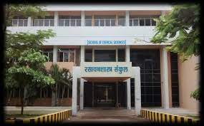

Five Years Integrated M.Tech Course in Cosmetic Technology:
Every human being wants to be attractive and fresh, which will improve his or her personality. Cosmetic Technology is a science which enhances the appearance or odour of the human body. The chemical compounds used in cosmetics, their preparation, testing and its developments from natural and synthetic sources is a rapidly developing field. The research of different products gives very high value addition and has very high economic importance in the commercial world. Cosmetic Technologies have been at the forefront of innovative personal care manufacturing for over twenty years. The course gives extensive knowledge of Cosmetic Formulation, Manufacturing, Analysis and Marketing. It also covers the fundamental aspects of cosmetic science that are necessary to understand material development, formulation, and the dermatological effect that result from the use of tissue products.

Highlights of Some Career Options after M.Tech Course in Cosmetic Technology:
Areas of employment:
- Beauty Product Companies
- Colleges & Universities
- Fashion Content Writing
- Luxurious Hotel & Resorts (Parlours)
- Spa Centers
- Television and Film Industries
Types of Job:
- Beauty Advisor
- Brand Executive
- Brand Manager
- Business Development Manager
- Lecturer
- Quality Control Analyst
- Research & Development Executive

Eligibility:
- Students with H.S.C. with Science Stream.
- Students with B.Sc.(B group) are eligible for the direct admission to 3rd year after successful completion of Breach course.
- Students with D.Pharm are eligible for the direct admission to 2nd year.
- Students with B.Pharm are eligible for the direct admission to 4th year.

Course Duration:
Integrated Five year (4+1)

Intake Capacity:
- 30

General Document Required:
- S.S.C(10th) Mark sheet and Certificate
- H.S.C(12th) Mark sheet and Certificate
- Leaving Certificate after passing H.S.C(12th)
- Nationality
- Adhar Card

Document Required By Reserved Category Candidates:
- Caste Certificate
- Caste Validity Certificate
- Non Creamy Layer Certificate.

About School of Technology:
School of Technology was established in 2018.In this school the integrated M.Tech. in Cosmetic Technology was initiated in 2018.The Course Started under the premises of School of Chemical Sciences. The course helps to advance the science of cosmetic and toiletries. There is special emphasis on the preparations from herbal and natural origins. Other benefits of this course is to encourage research and development in cosmetic and related sciences. This course also gives them good and solid base for further studies in this field. The school is having well equipped Labs, smart digital classrooms. Students prepare and analyze various Cosmetic preparations in the laboratory. Hostel and Canteen facilities are available in the campus.
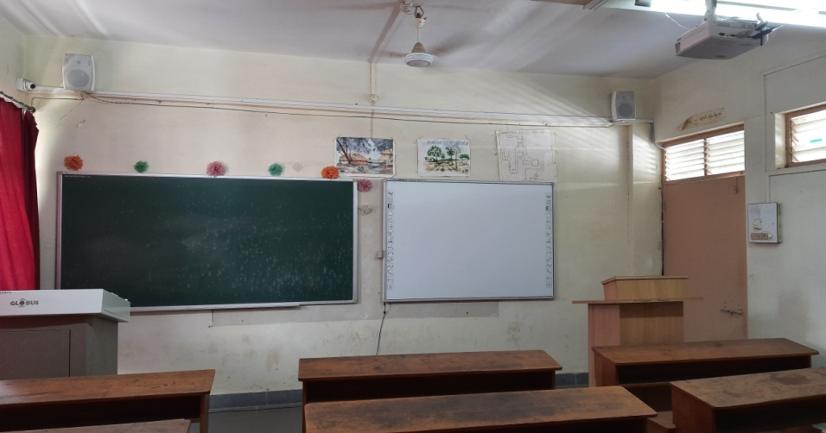
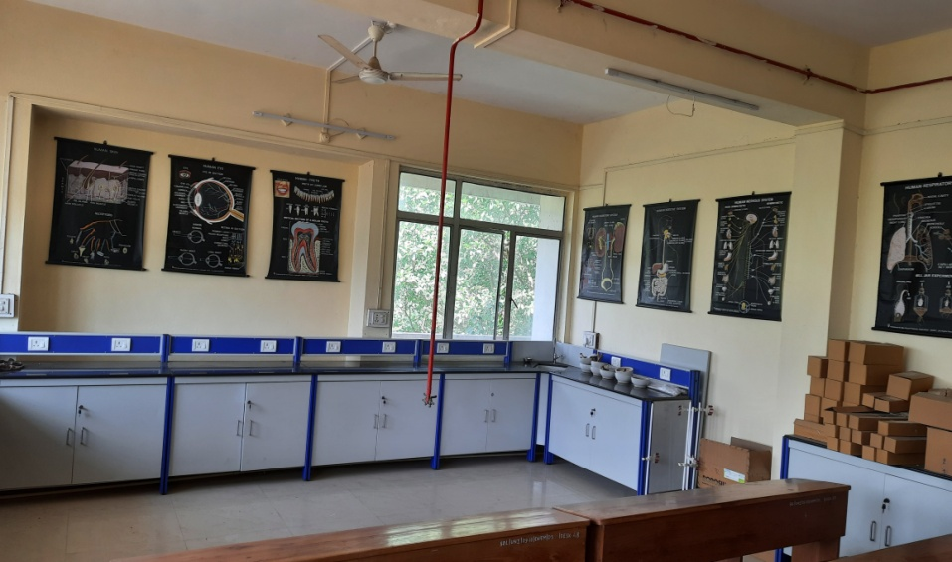

Cosmetic technology laboratory:

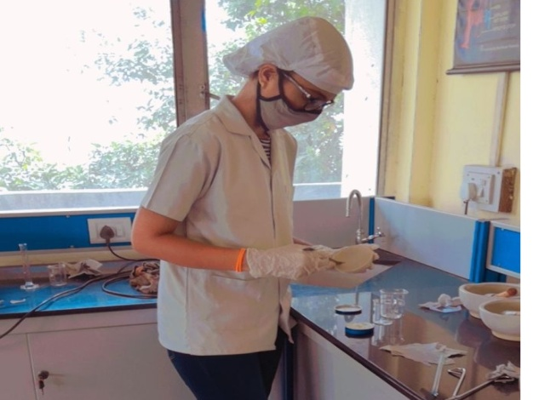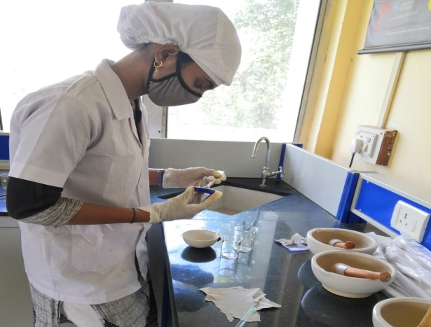

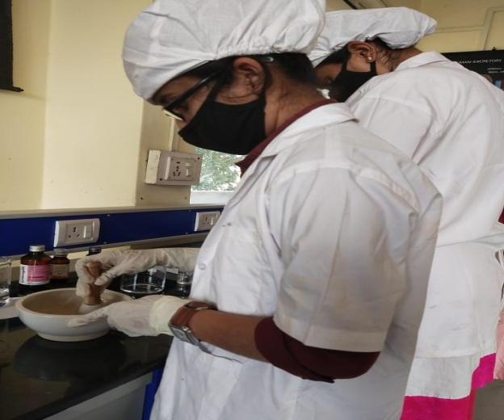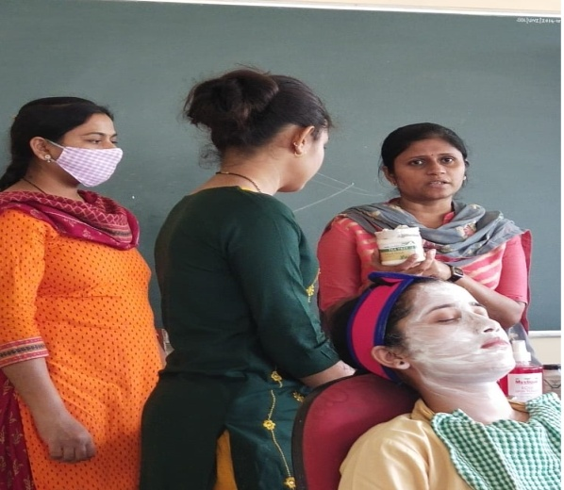
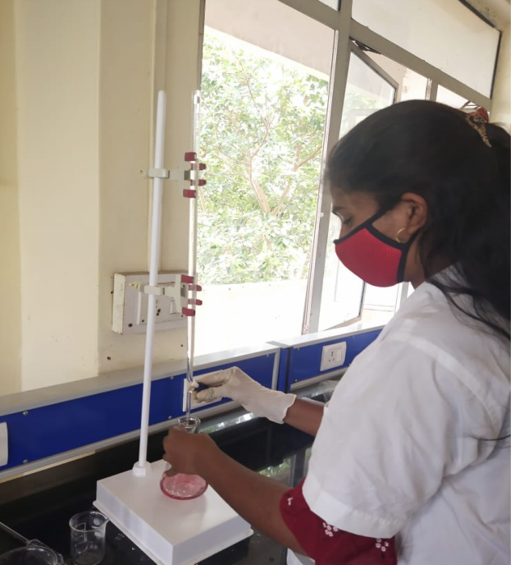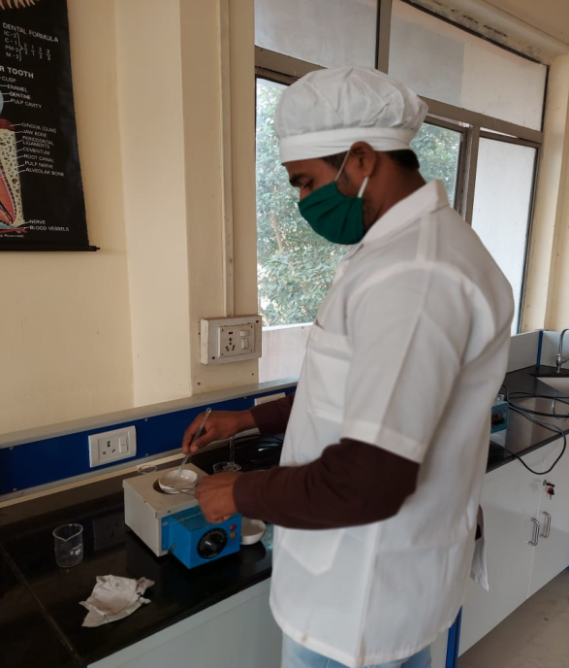

Cosmetics Preparation and Extract of natural ingredient:

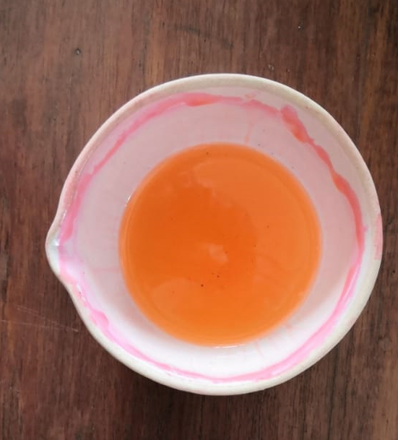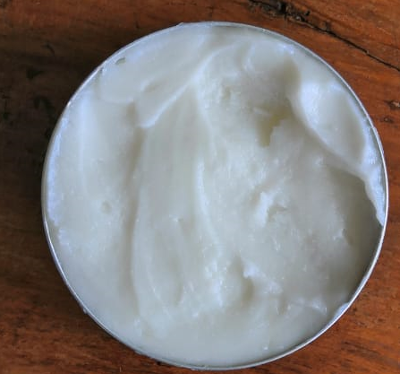
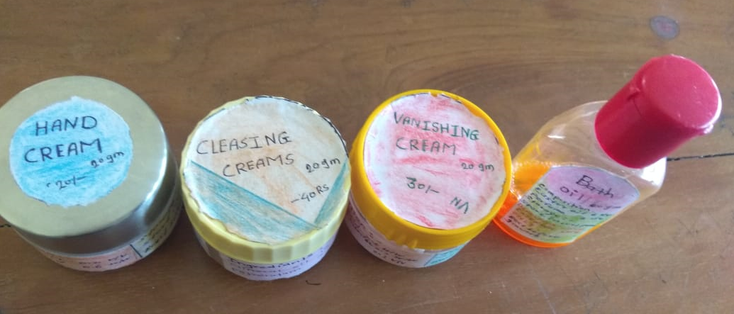
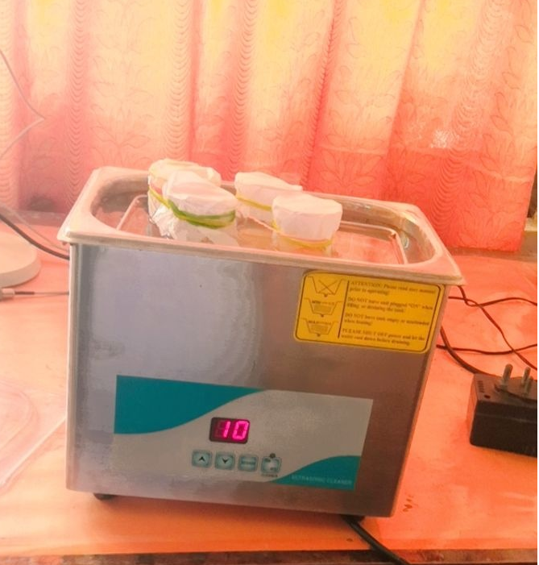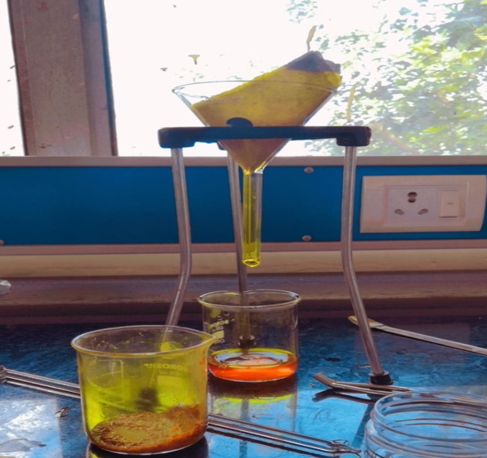

Various Activities by School and Students:
- School arranged Webinar on Career and Opportunities in Cosmetic Technology.
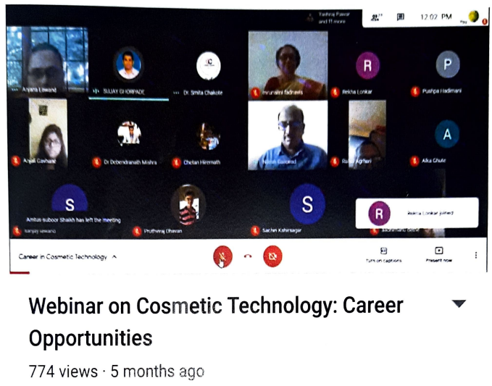
- Students participated in E-Poster Competition held on the occasion of Voters day and won the prize.

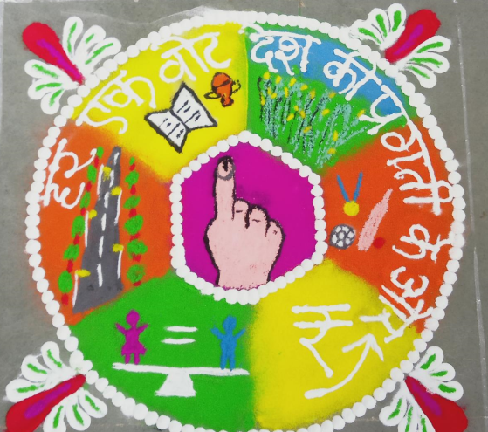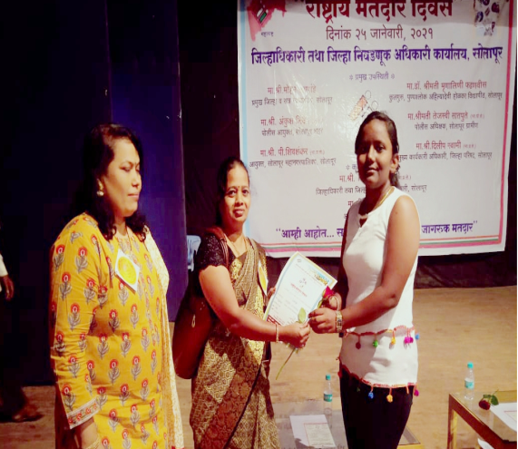

Teaching Staff:

I/C Director – Dr. Mrs. A. S. Lawand.
Current teaching faculty for AY 2020-21.
Sr.No. | Name of Faculty | Designation | Qualification
1 | Dr.L.S.Walekar | Assistance Professor | Ph.D, Post Doct.
2 | G.B.Jagtap | Assistance Professor | M.Pharm.
3 | S.S.Kawathekar | Assistance Professor | M.Pharm.
4 | S.G.Pore | Assistance Professor | M.Pharm.
5 | S.A.Ghorpade | Assistance Professor | M.sc.Chemistry
Details of Course Structure:
First Year Integrated M.Tech. in Cosmetic Technology:
Semester | Code | Title of the Paper | Semester Examination |  |  | L | T | P | Credits
 |  |  | Theory (UA) | CA | Total
Sem-I |  | Hard Core
 | HCT1.1 | Cosmetic Chemistry - I | 40 | 10 | 50 | 4 | -- | -- | 4
 | HCT1.2 | Anatomy & Physiology - I | 40 | 10 | 50 | 4 | -- | -- | 4
 | HCT1.3 | Natural Cosmetic Agents-I | 40 | 10 | 50 | 4 | -- | -- | 4
 | HCT1.4 | English (Compulsory) | 40 | 10 | 50 | 2 |  |  | 2
 |  | Soft Core (Any one)
 | SCT1.1 | Elementary Mathematics | 40 | 10 | 50 | 4 | -- | -- | 4
 | SCT1.2 | Elementary Statistics | 40 | 10 | 50 | 4 | -- | -- | 4
 |  | Seminar/Tutorial/ Industrial Visit/ Field Tour | --- | 10 | 10 | -- | 1 | -- | 1
 | HCP1.1 | Practical-I | 40 | 10 | 50 | -- | -- | 08 | 4
 | HCP1.2 | Practical-II | 40 | 10 | 50 | -- | -- | 08 | 4
 | Total for Semester-I |  | 280 | 80 | 360 | 18 | 01 | 16 | 27
Sem-II |  | Hard Core
 | HCT2.1 | Cosmetic Chemistry - II | 40 | 10 | 50 | 4 | -- | -- | 4
 | HCT2.2 | Anatomy & Physiology - II | 40 | 10 | 50 | 4 | -- | -- | 4
 | HCT2.3 | Natural Cosmetic Agents - II | 40 | 10 | 50 | 4 | -- | -- | 4
 | HCT2.4 | English (Compulsory) | 40 | 10 | 50 | 2 |  |  | 2
 | HCT2.5 | Democracy, Elections and Good Governance | 40 | 10 | 50 | 3 | -- | -- | NC
 |  | Soft Core (Any one)
 | SCT2.1 | Fundamental Chemistry | 40 | 10 | 50 | 4 | -- | -- | 4
 | SCT2.2 | Analytical Chemistry | 40 | 10 | 50 | 4 | -- | -- | 4
 |  | Seminar/Tutorial/ Industrial Visit/ Field Tour | --- | 10 | 10 | -- | 1 | -- | 1
 | HCP2.1 | Practical-III | 40 | 10 | 50 | -- | -- | 08 | 4
 | HCP2.2 | Practical-IV | 40 | 10 | 50 | -- | -- | 08 | 4
 | Total for Semester-II |  | 320 | 90 | 410 | 21 | 01 | 16 | 27

Second Year Integrated M.Tech. in Cosmetic Technology:
Semester | Code |  | Title of the Paper | Semester Examination |  |  | L | T | P | Credits
 |  |  |  | Theory  (UA) | CA | Total
Sem-III |  |  | Hard Core
 | HCT3.1 |  | Cosmetic Technology-I | 40 | 10 | 50 | 4 | -- | -- | 4
 | HCT3.2 |  | Instrumental methods of  Analysis - I | 40 | 10 | 50 | 4 | -- | -- | 4
 | HCT3.3 |  | Cosmetic Engineering - I | 40 | 10 | 50 | 4 | -- | -- | 4
 | HCT3.4 |  | Cosmetic Chemistry III | 40 | 10 | 50 | 4 | -- | -- | 4
 |  |  | Soft Core (Any one)
 | SCT3.1 |  | Drug & Cosmetic Laws-I | 40 | 10 | 50 | 4 | -- | -- | 4
 | SCT3.2 |  | Introductory Pharmacology  and Toxicology-I | 40 | 10 | 50 | 4 | -- | -- | 4
 |  |  | Seminar/Tutorial/ Industrial Visit/ Field Tour | --- | 10 | 10 | -- | 1 | -- | 1
 | HCP3.1 |  | Practical-I(HCT3.1 and HCT3.2) | 40 | 10 | 50 | -- | -- | 04 | 4
 | HCP3.2 |  | Practical-II(HCT3.3and HCT3.4) | 40 | 10 | 50 | -- | -- | 04 | 4
 | Total for Semester-III |  |  | 280 | 80 | 360 | 20 | 01 | 08 | 29
Sem-IV |  | Hard Core
 | HCT4.1 | Cosmetic Technology - II |  | 40 | 10 | 50 | 4 | -- | -- | 4
 | HCT4.2 | Instrumental methods of  Analysis - II |  | 40 | 10 | 50 | 4 | -- | -- | 4
 | HCT4.3 | Cosmetic Engineering - II |  | 40 | 10 | 50 | 4 | -- | -- | 4
 | HCT4.4 | Cosmetic Chemistry - IV |  | 40 | 10 | 50 | 4 | -- | -- | 4
 | HCT4.5 | Environmental Studies |  | 40 | 10 | 50 | 3 | -- | -- | NC
 |  | Soft Core (Any one)
 | SCT4.1 | Drug & Cosmetic Laws - II |  | 40 | 10 | 50 | 4 | -- | -- | 4
 | SCT4.2 | Introductory Pharmacology  and Toxicology-II |  | 40 | 10 | 50 | 4 | -- | -- | 4
 |  | Seminar/Tutorial/ Industrial Visit/ Field Tour |  | --- | 10 | 10 | -- | 1 | -- | 1
 | HCP4.1 | Practical-III(HCT4.1 & HCT4.2) |  | 40 | 10 | 50 | -- | -- | 04 | 4
 | HCP4.2 | Practical-IV(HCT4.3 & HCT4.4) |  | 40 | 10 | 50 | -- | -- | 04 | 4
 | Total for Semester-IV |  |  | 320 | 90 | 410 | 23 | 01 | 08 | 29

Third Year Integrated M.Tech. in Cosmetic Technology:
Semester | Code | Title of the Paper | Semester Examination |  |  | L | T | P | Credits
 |  |  | Theory | IA | Total
Sem-V |  | Hard Core
 | HCT5.1 | Perfume I | 70 | 30 | 100 | 4 | -- | -- | 4
 | HCT5.2 | Cosmetic Technology III | 70 | 30 | 100 | 4 | -- | -- | 4
 | HCT5.3 | Principles of Cosmecutics - I | 70 | 30 | 100 | 4 | -- | -- | 4
 | HCT5.4 | Beauty Culture – I | 70 | 30 | 100 | 4 | -- | -- | 4
 |  | Soft Core (Any one)
 | SCT5.1 | Cosmetic Engineering III | 70 | 30 | 100 | 4 | -- | -- | 4
 | SCT5.2 | Pharmacology & Interaction-I | 70 | 30 | 100 | 4 | -- | -- | 4
 |  | Seminar/Tutorial/ Industrial Visit/ Field Tour | --- | 25 | 25 | -- | 1 | -- | 1
 |  | Minor Project | --- | 25 | 25 | -- |  | 1 | 1
 | HCP5.1 | Practical-I | 70 | 30 | 100 | -- | -- | 06 | 4
 | HCP5.2 | Practical-II | 70 | 30 | 100 | -- | -- | 06 | 4
 | Total for Semester– V |  | 490 | 260 | 750 | -- | -- | -- | 30
Sem-IV |  | Hard Core
 | HCT6.1 | Perfume II | 70 | 30 | 100 | 4 | -- | -- | 4
 | HCT6.2 | Cosmetic Technology IV | 70 | 30 | 100 | 4 | -- | -- | 4
 | HCT6.3 | Principles of Cosmecutics - II | 70 | 30 | 100 | 4 | -- | -- | 4
 | HCT6.4 | Beauty Culture – II | 70 | 30 | 100 | 4 | -- | -- | 4
 |  | Soft Core (Any one)
 | SCT6.1 | Cosmetic Engineering IV | 70 | 30 | 100 | 4 | -- | -- | 4
 | SCT6.2 | Pharmacology & Interaction-II | 70 | 30 | 100 | 4 | -- | -- | 4
 |  | Seminar/Tutorial/ Industrial Visit/ Field Tour | --- | 25 | 25 | -- | 1 | -- | 1
 |  | Minor Project | --- | 25 | 25 | -- |  | 1 | 1
 | HCP6.1 | Practical-III | 70 | 30 | 100 | -- | -- | 06 | 4
 | HCP6.2 | Practical-IV | 70 | 30 | 100 | -- | -- | 06 | 4
 | Total for Semester-VI |  | 490 | 260 | 750 | -- | -- | -- | 30

Fourth Year Integrated M.Tech. in Cosmetic Technology:
Semester | Code |  | Title of the Paper | Semester Examination |  |  | L | T | P | Credits
 |  |  |  | Theory  (UA) | CA | Total
Sem-VII |  |  | Hard Core
 | HCT7.1 |  | Perfumes &Colours-I | 70 | 30 | 100 | 4 | -- | -- | 4
 | HCT7.2 |  | Cosmetic Technology- V | 70 | 30 | 100 | 4 | -- | -- | 4
 | HCT 7.3 |  | Quality Assurance Techniques | 70 | 30 | 100 | 4 | -- | -- | 4
 | HCT 7.4 |  | Herbal Cosmetics-I | 70 | 30 | 100 | 4 | -- | -- | 4
 |  |  | Soft Core (Any one)
 | SCT 7.1 |  | Organization & Management of Industries | 70 | 30 | 100 | 4 | -- | -- | 4
 | SCT 7.2 |  | Material Management  & Inventory Control | 70 | 30 | 100 | 4 | -- | -- | 4
 |  |  | Seminar/Tutorial/ Industrial Visit/ Field Tour | --- | 25 | 25 | -- | 1 | -- | 1
 | HCP 7.1 |  | Practical-I(HCT 7.1 &HCT 7.2) | 70 | 30 | 100 | -- | -- | 06 | 4
 | HCP 7.2 |  | Practical-II (HCT 7.3 &HCT 7.4) | 70 | 30 | 100 | -- | -- | 06 | 4
 | Total for Semester- VII |  |  | 490 | 235 | 725 | -- | -- | -- | 29
Sem-VIII |  | Hard Core
 | HCT 8.1 | Perfumes &Colours- II |  | 70 | 30 | 100 | 4 | -- | -- | 4
 | HCT 8.2 | Cosmetic Technology- VI |  | 70 | 30 | 100 | 4 | -- | -- | 4
 | HCT 8.3 | Cosmeceuticals Microbiology |  | 70 | 30 | 100 | 4 | -- | -- | 4
 | HCT 8.4 | Herbal Cosmetics-II |  | 70 | 30 | 100 | 4 | -- | -- | 4
 |  | Soft Core (Any one)
 | SCT 8.1 | Management and Organizational Behavior |  | 70 | 30 | 100 | 4 | -- | -- | 4
 | SCT 8.2 | Plant Design |  | 70 | 30 | 100 | 4 | -- | -- | 4
 |  | Dissertation /Implant/ Review |  | --- | 25 | 25 | -- | 1 | -- | 1
 | HCP 8.1 | Practical-III (HCT 8.1 &HCT 8.2) |  | 70 | 30 | 100 | -- | -- | 06 | 4
 | HCP 8.2 | Practical-IV(HCT 8.3 &HCT 8.4) |  | 70 | 30 | 100 | -- | -- | 06 | 4
 | Total for Semester- VIII |  |  | 490 | 235 | 725 | -- | -- | -- | 29

L=Lecture T=Tutorials P=Practical IA=Internal Assessment, HCT=Hard Core Theory SCT=Soft Core Theory, HCP=Hard Core Practical

